**Week5**

**PORTFOLIO**

**Assessment Weightage & Type:**

**60% Portfolio Coursework**

**Year:2024**

* Student Name: Pratha Sharma
* UWE ID: 24030176
* Module code: **UFCFL1-15-0**
* Level: **Level 3)**
* Faculty: **Faculty of Internet & Technology**
* Department: **FET Department of Computer Science & Creative**

**Technology**

**Week 5**

**Exercise-1**

Write the HTML code which use of:

▪ The italics tag

▪ The Center tag

▪ The paragraph tag

▪ The Break tag

▪ The Font tag and its attributes

**Code:**

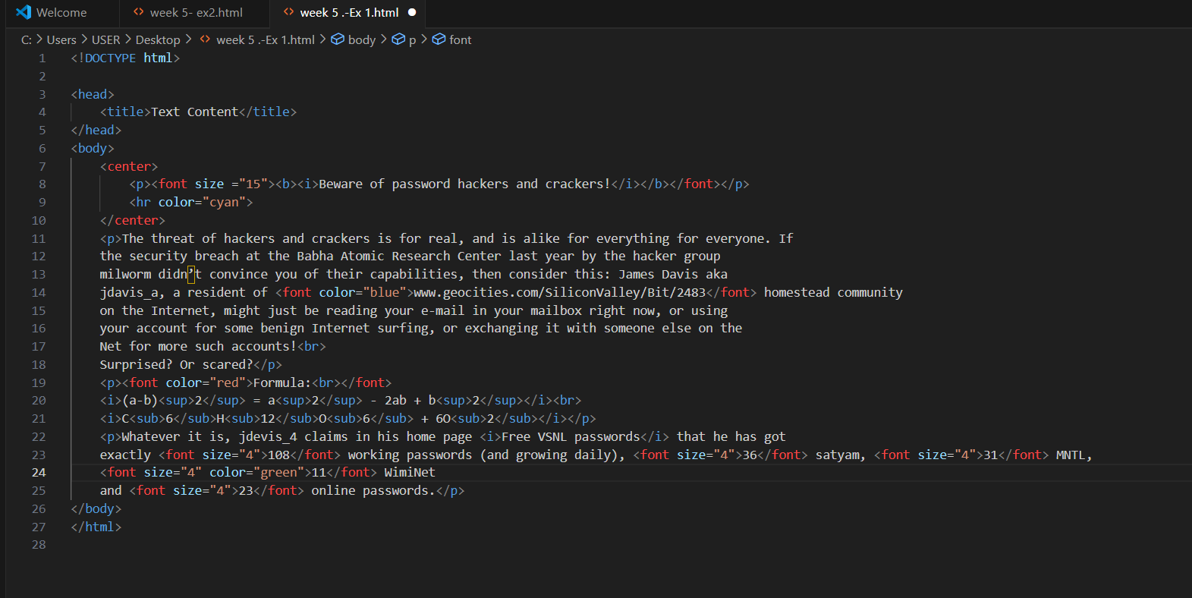

**Website:**

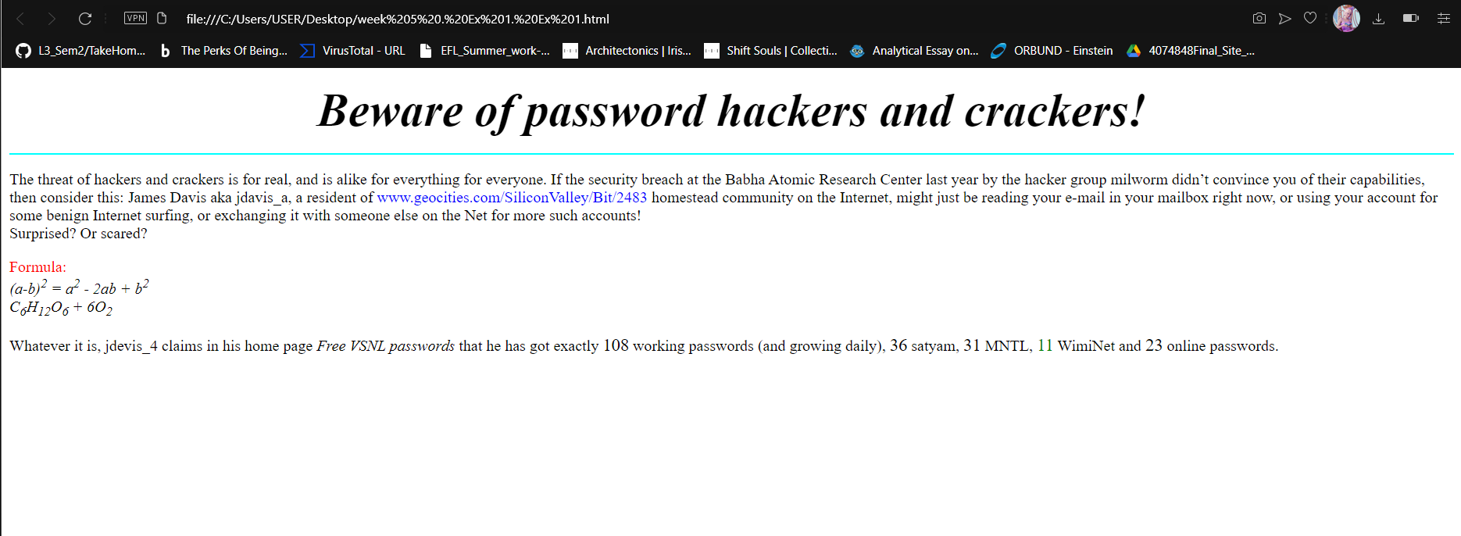

**Exercise-2**

Looking at the screen given below write the HTML code making use of following tags

. Unordered Lists

. Ordered Lists

. Definition Lists

. Heading tag

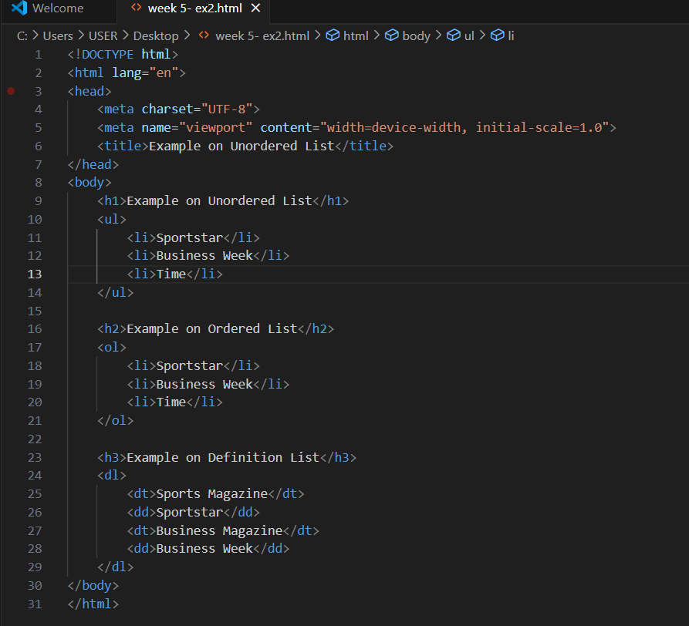

**Website:**

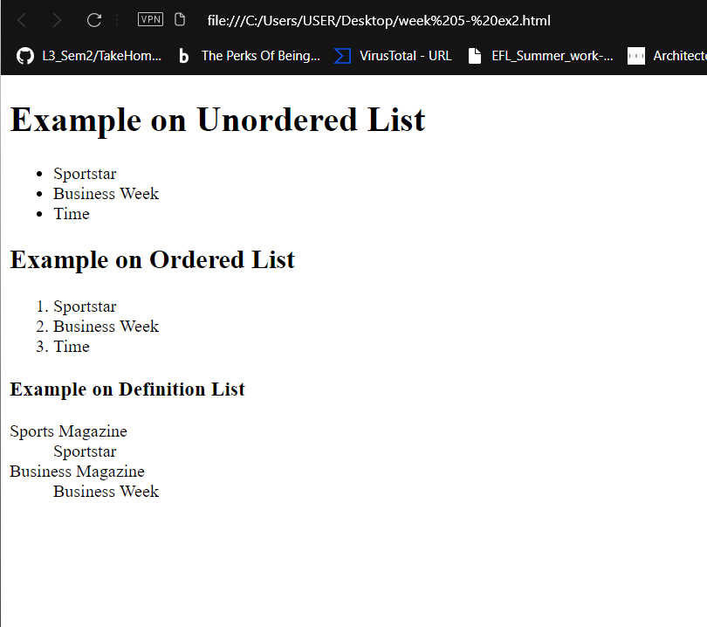

**Exercise-3**

Design a two web page according to the following specifications.

Page 1 detail:

Use “landscape.jpg” image as page background and display the content on top of it. Text

content should visible, background image should not affect the text content.

Page 2 detail:

Use “BLACK color” as background color and display text content on top of it using

“WHITE color”

Code1:

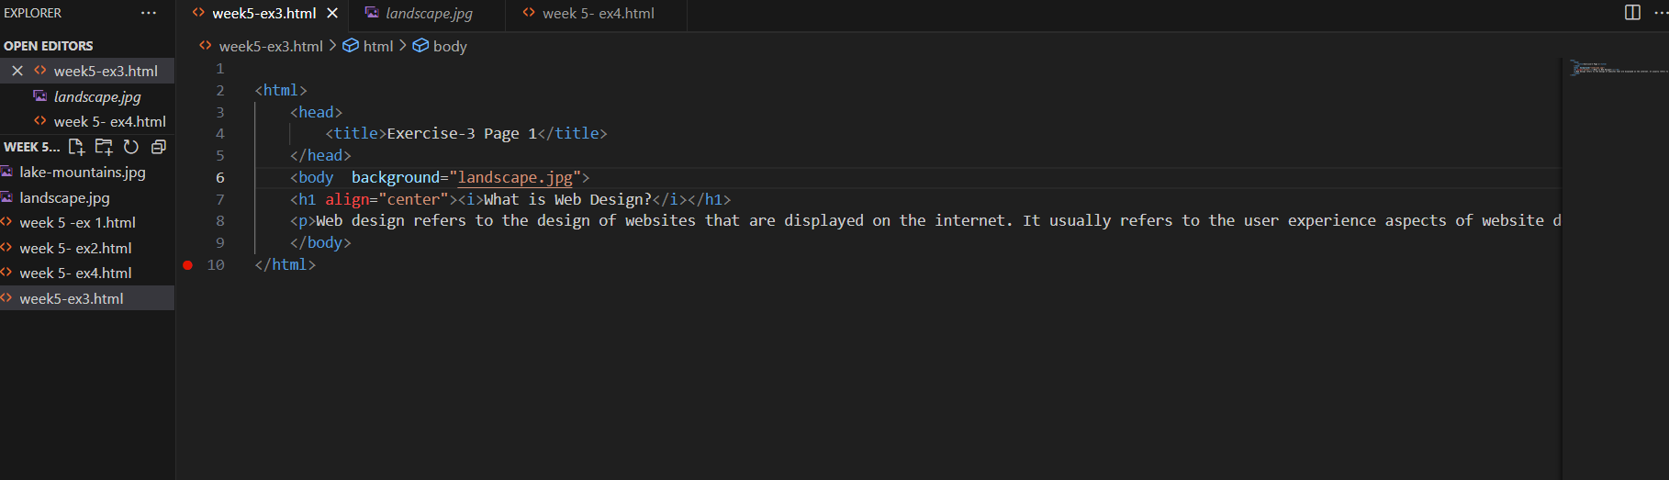

Website1:

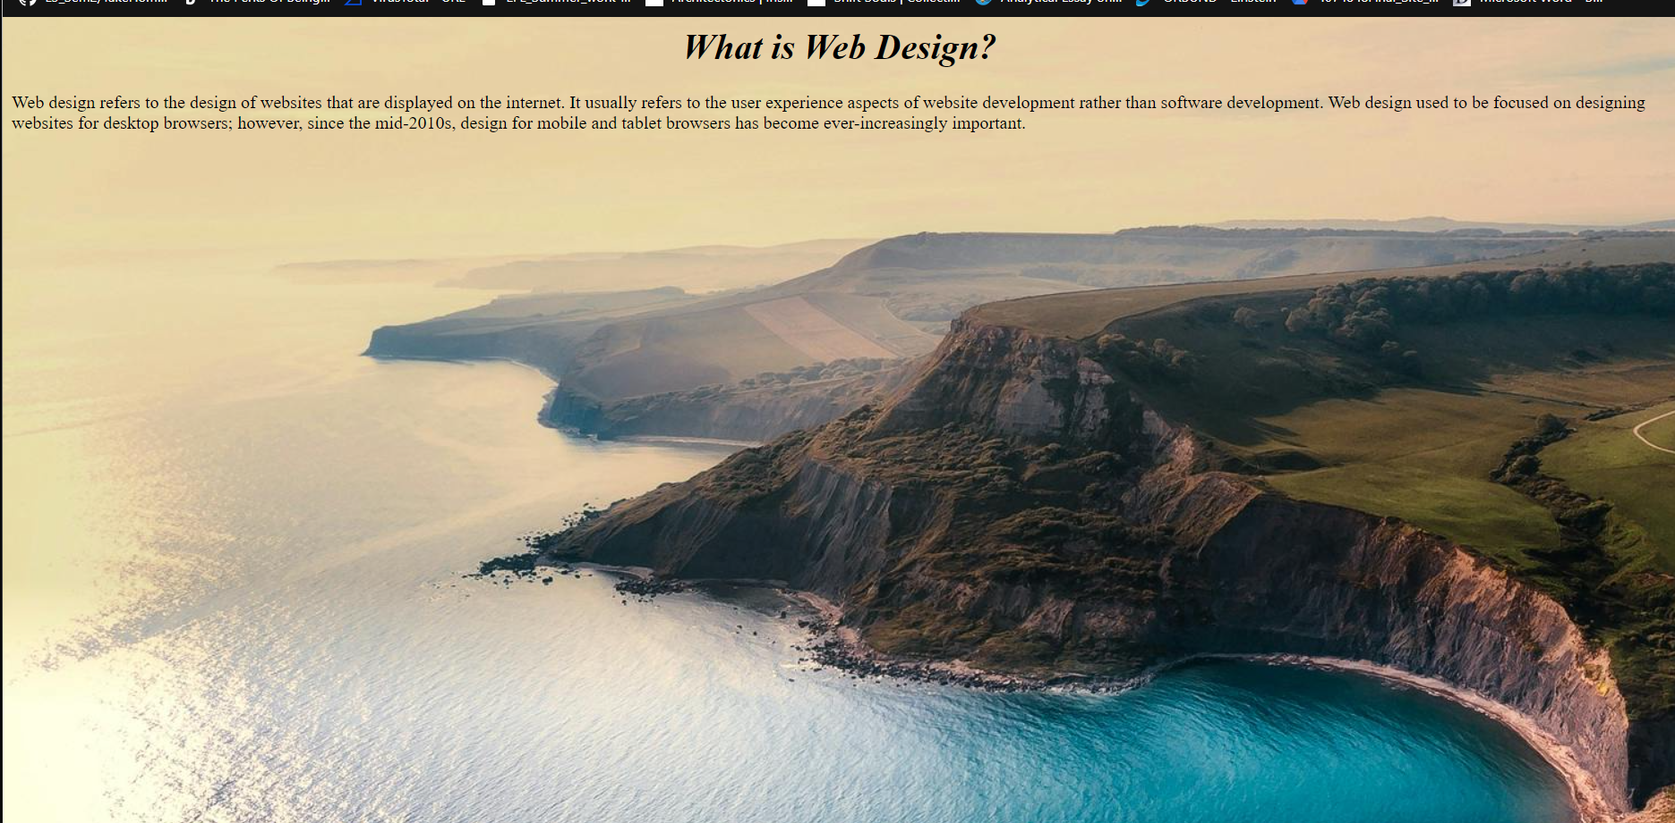

Code2:

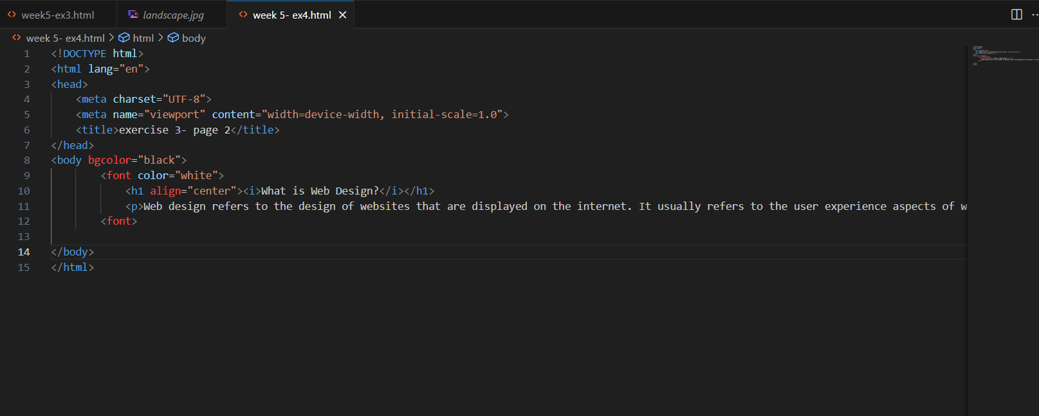

Website2:

